10 PRACTICE QUESTIONS
DSA0502 QUERY PROCESSING FOR DATA SCIENCE

1.Perform Complete Data Wrangling on a Student Dataset
1.Read a CSV file, remove duplicate records, handle missing values, rename columns, change data types, and save the cleaned dataset.

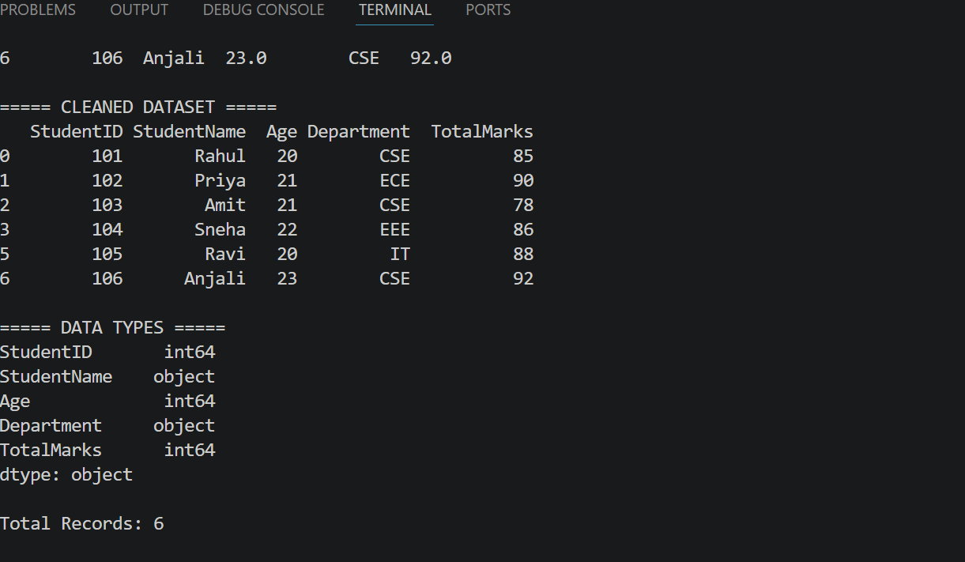

2.Merge Student, Department, and Marks Datasets
1.Read multiple CSV files and merge them using common keys (StudentID and DepartmentID) to generate a consolidated student report.

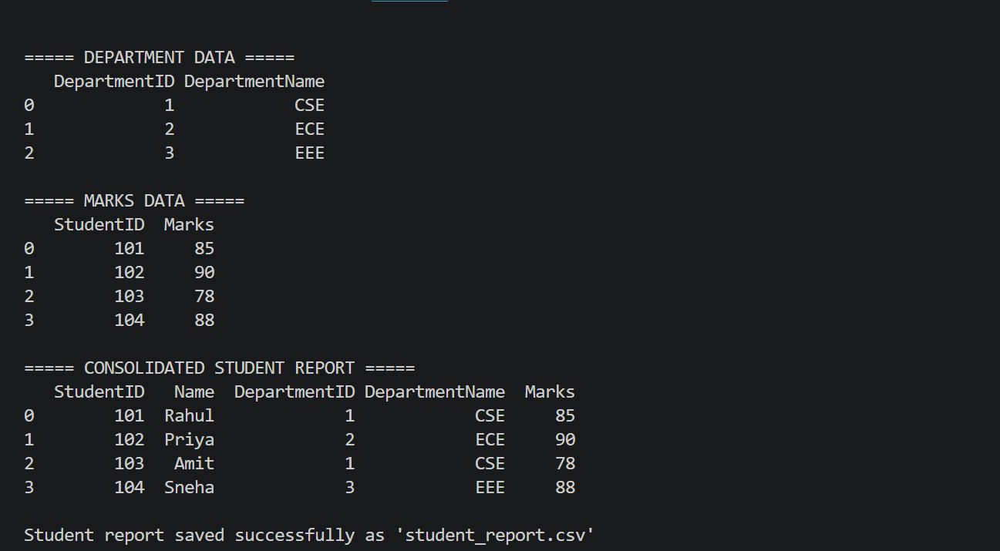
3.Convert Data Between Multiple Formats
1.Read data from a CSV file, convert it to JSON and XML formats, and verify the converted data by reading the generated files.

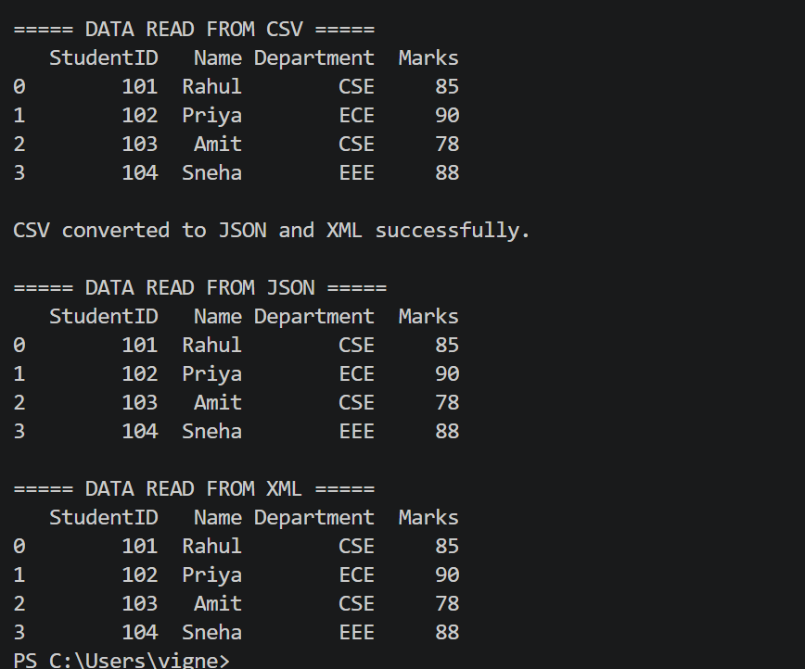

4.Analyze Student Performance Using Pandas
1.Calculate highest, lowest, average, median, and standard deviation of marks, assign grades based on marks, and identify top-performing students.

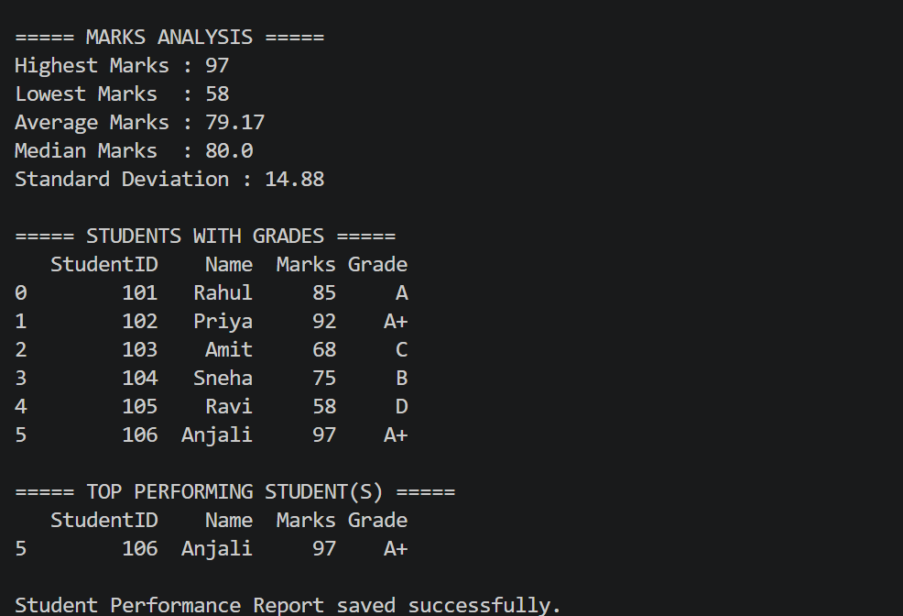

5.Read Data from an SQLite Database and Generate Reports
1.Connect to an SQLite database, retrieve records using SQL queries, filter data based on conditions, and export the results to a CSV file.

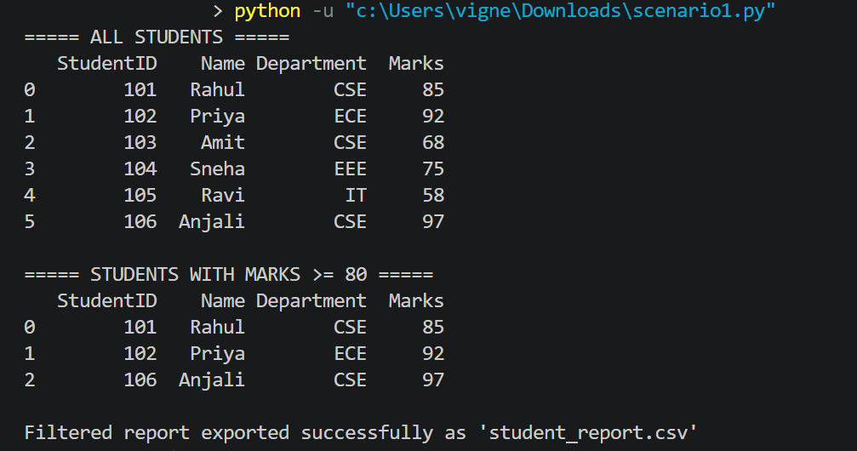

6.Create and Analyze a Database Schema
1.Create Student, Course, and Marks tables in SQLite, define primary and foreign keys, insert records, and retrieve data using SQL JOIN operations.
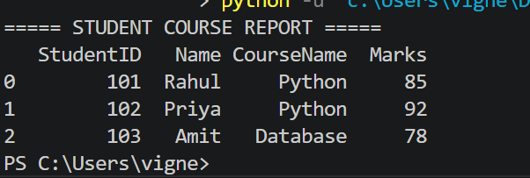
7.Data Validation and Error Detection
1.Validate a dataset by detecting missing values, duplicate records, invalid email addresses, incorrect phone numbers, and negative marks, then generate a cleaned dataset.
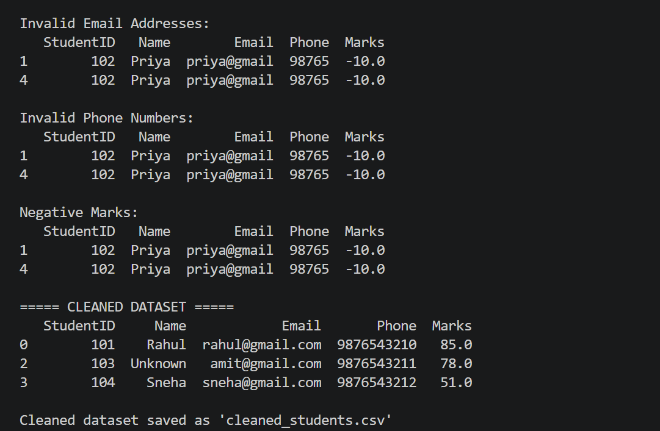
8.Build a Mini Data Wrangling Pipeline
1.Read data from CSV, JSON, and XML files, combine them into a single DataFrame, clean the data, remove inconsistencies, and save the final output.
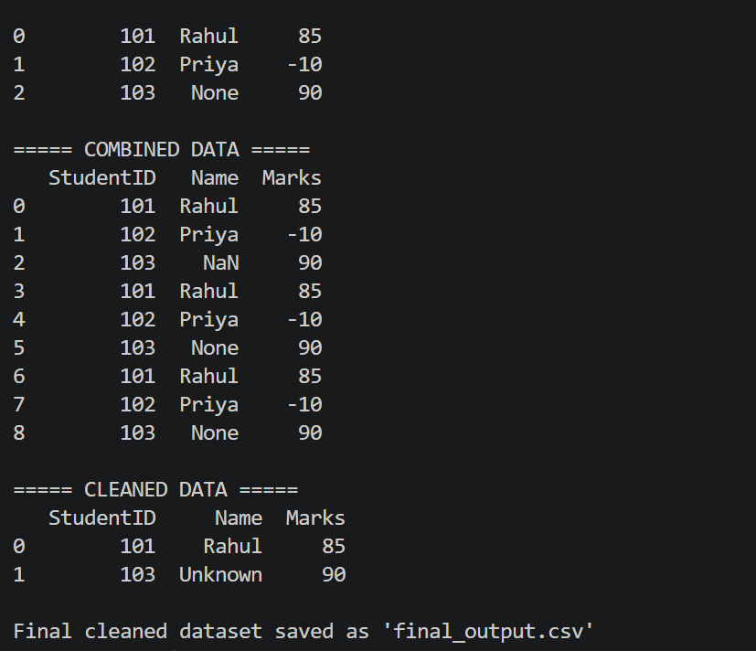
9.Employee Payroll Data Analysis
1.Import employee payroll data, calculate net salary, identify employees with the highest salary, generate department-wise salary summaries, and export the report.
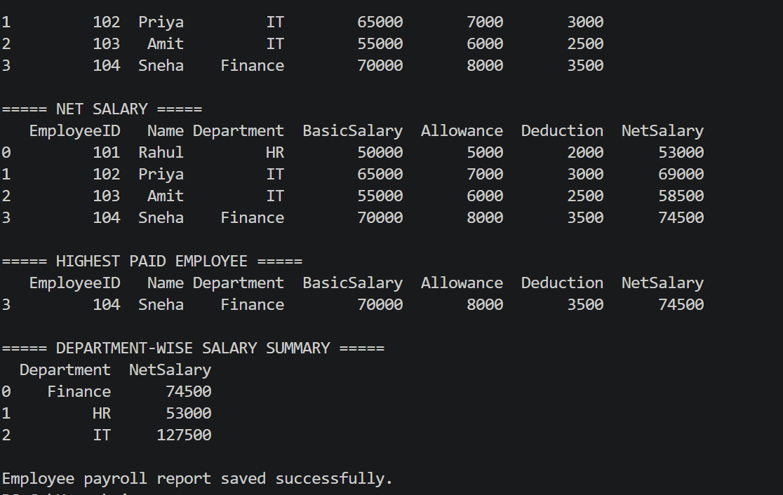
10.Sales Data Analysis Dashboard
1.Read monthly sales data from multiple CSV files, merge them into a single dataset, calculate total sales, monthly revenue, top-selling products, and generate summary reports using Pandas.
